Manuscript Template

Title

Scattering Properties of a Suspension Containing Plate-like Particles and Their Aggregates

First Name Last Name and First Name Last Name

Budi Andi,* and Bella Agus²

¹Vocational Education Program, Financial Administration and Banking Studies Program, Universitas Ciputra, Surabaya, Indonesia
²Vocational Education Program, Therapy Occupation Studies Program, Universitas Ciputra, Surabaya, Indonesia

*Corresponding author: Budi Andi; Email: email@gmail.com

Abstract – One paragraph (150–250 words)
The results of the scattering matrix measurements at a wavelength of 0.63 μm are presented for an aqueous suspension of lead oxide containing plate-like particles and their aggregates with monomers dimensions of ~ 5 nm. The results of the measurements are compared with the matrix calculations for axially symmetric scatterers (ellipsoids of revolution). It is shown that the presence of aggregates affects the scattering properties of such a medium. The particles size distribution of the dispersed medium was found by solving the problem of minimizing the sum of the squares of the deviations of the experimental values of the matrix elements from calculated using the model of axially symmetric scatterers. It is demonstrated that the particle size distribution is more accurately retrieved by minimizing the sum of the squares of the deviations for the sum of the diagonal elements. The obtained distribution is compared with one measured by the dynamic light scattering method.

Keywords: scattering matrix, aggregates, particle size distribution (minimum 3 keywords are required, separated by comma (,))
Citation can be APA Style or numbered

- Introduction

For laser methods for the diagnosis of disperse media based on detecting scattered radiation, high sensitivity and speed are characteristic; they are non-invasive and remote [1, 2]. In this article, the results of measurements of the scattering matrix of an aqueous suspension of lead oxide whose particles are plate-shaped are presented; and the possibility of reconstructing the distribution parameters of the particles of the dispersed phase by interpreting of experimental data using the model of axially symmetric (spheroidal) scatterers is considered.

- Literature Review

The literature review represents the theoretical core of an article. In this section, we will discuss the purpose of a literature review. We will also consider how one should go about to find appropriate literature on which to base a literature review and how this information should be managed. Finally, we will answer four questions that first-time researchers often battle with when compiling a literature review.
These questions are: which aspects should I include in a literature review?;how should I go about synthesizing information in a literature review?; how should I structure a literature review? what writing style should I use when compiling a literature review?
The purpose of a literature review is to “look again” (re + view) at what other researchers have done regarding a specific topic (Leedy & Ormrod 2005:70). A literature review is a means to an end, namely to provide background to and serve as motivation for the objectives and hypotheses that guide your own research (Perry et al. 2003:660) A good literature review does not merely summarise relevant previous research. In the literature review, the researcher critically evaluates, re-organizes and synthesizes the work of others (Leedy & Ormrod, 2005:84). In a sense, compiling a literature review is like making a smoothie or fruit shake: The end product is a condensed mix that differs totally in appearance from the individual ingredients used as inputs. The key to a successful literature review lies in your ability to “digest” information from different sources, critically evaluate it and resent your conclusions in a concise, logical and reader-friendly” manner.
First-time researchers often naively believe everything they read or are scared to criticize the work of others. However, academic research is all about critical inquiry! It is, therefore, extremely important that you critically evaluate the material that you read. Do you agree with the arguments and conclusions of other researchers? If you disagree, why? Can you identify contradictory arguments or findings? How could one explain these contradictions? Do the findings of previous studies apply in all contexts or are the findings context-specific? What are the criticisms against the conceptual models or measurement approaches discussed in the literature? Which limitations should be considered when interpreting the results of previous research?
You have to carefully read the most recent available literature to identify specific gaps, inconsistencies and/or controversies that may form the basis of your own research. Always show that you have considered an issue from several angles and that you are aware of the arguments for and against a specific point of view. Many researchers in services marketing, for example, use the SERVQUAL measurement scale without considering existing criticisms against it.
To compile a proper literature review, one has to overcome three specific challenges: finding appropriate literature on a specific topic, managing the information, and presenting a logical, synthesized, and reader-friendly review of the current knowledge relating to a specific topic. Consider the following search strategies: Blackwell Synergy; Proquest Data Basis; EBSCOhost (Business Source Premier and Business Source Premier); Emerald; Taylor and Francis; Infotrac; Wiley Interscience; and others.
Section headings should be left justified, bold, with the first letter capitalized, starting with the Introduction. Sub-section headings should be in capital and lower-case italic letters and left justified, with second and subsequent lines indented. All headings should have a minimum of three text lines after them before a page or column break. Ensure the text area is not blank except for the last page.
General guidelines for the preparation of your text. Avoid hyphenation at the end of a line. Symbols denoting vectors and matrices should be indicated in bold type. Scalar variable names should normally be expressed using italics. Weights and measures should be expressed in SI units. All non-standard abbreviations or symbols must be defined when first mentioned, or a glossary provided.
File naming and delivery
All figures should be numbered with Arabic numerals (1,2,3,….). Every figure should have a caption. All photographs, schemas, graphs and diagrams are to be referred to as figures. Line drawings should be good quality scans or true electronic output. Low-quality scans are not acceptable. Figures must be embedded into the text and not supplied separately. In MS word input the figures must be properly coded. Preferred format of figures are PNG, JPEG, GIF etc. Lettering and symbols should be clearly defined either in the caption or in a legend provided as part of the figure. Figures should be placed at the top or bottom of a page wherever possible, as close as possible to the first reference to them in the paper. Please ensure that all the figures are of 300 DPI resolutions as this will facilitate good output.
The figure number and caption should be typed below the illustration in 8 pt and left justified [Note: one-line captions of length less than column width (or full typesetting width or oblong) centered]. For more guidelines and information to help you submit high quality artwork please visit: http://www.elsevier.com/artworkinstructions Artwork has no text along the side of it in the main body of the text. However, if two images fit next to each other, these may be placed next to each other to save space. For example, see Fig. 1.

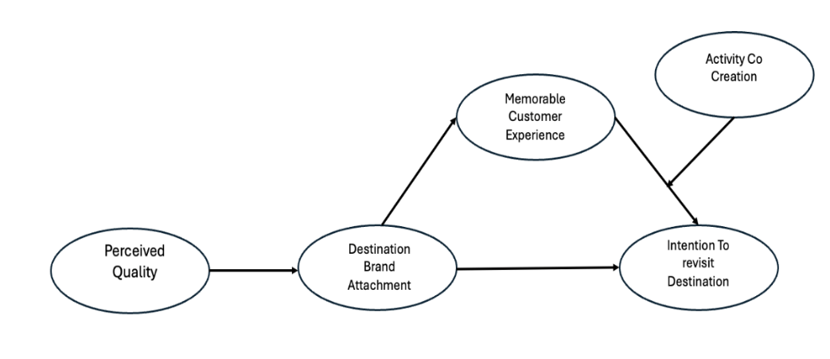
Figure 1. xxx

Equations and formulae should be typed in Math type and numbered consecutively with Arabic numerals in parentheses on the right-hand side of the page (if referred to explicitly in the text). They should also be separated from the surrounding text by one space.

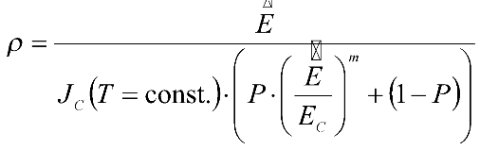

- Methods
  - Methods
    - Diagrammatic representation
Figure and Table citations
An aqueous suspension of PbO particles was studied, the micrographs of which are shown in Figure 1. The refractive index of lead oxide is 2.61 [3], and PbO is considered to be a material that does not absorb radiation with a wavelength of 0.63 μm. PbO particles are plates with rounded edges in Table 1. Along with particles of coarse fraction (100–400 nm), the suspension contains fine particles (2–10 nm), which form aggregates [4–6]. The histograms of the particle size distribution of the coarse and fine fractions are shown in Figure 2, where r is the radius of the circle having an
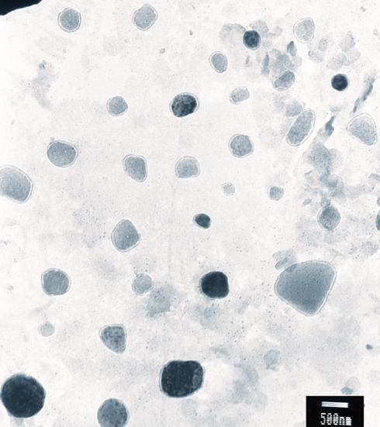 | 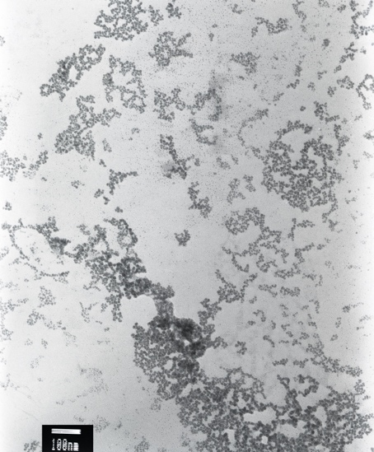
a | b
Figure 1: Microphotographs of particles of PbO, coarse fraction (a), aggregates (b).

Figure 2: Histograms of particle size distribution of PbO, fine fraction (a), coarse fraction (b).

area equal to the effective area of the particle. According to estimates (based on microphotographs), the fraction of coarse fraction is 10^{–4} – 10^{–5}.
The scattering matrices were measured by laser polarimeter, where a single-mode He–Ne laser with a wavelength of 0.63 µm and a power of 7 mW was used as a radiation source. The measurements were carried out in the scattering angle range of 10°–155°.

- Results

The experimental dependences of the matrix elements on the scattering angle for the lead oxide suspension are shown in Figure 3. In it f_{ij} are the matrix elements F_{ij} normalized on F₁₁ (f_{ij} = F_{ij}/F₁₁). Using the model of axially symmetric scatterers, the experimental data were approximated, in which the matrix elements F_{ij} were represented as the sum of the contributions of particles of different types to the resulting scattering matrix:
(1)
where θ_{k} is the scattering angle, α_{p} is the contribution of the corresponding type of particles to the scattering matrix, – the scattering cross section, and are the matrix elements of the p-th kind of particles. In the approximation, the contributions α_{i} of particles of different sorts were determined, which ensure a minimum of the sum of the squared deviations of the theoretical values of all matrix elements from the experimental (Φ₁).

For the 16 sets of four ε values considered, the smallest values of the sum of the squares of the deviations were obtained during simulating the particles of the medium by oblate spheroids with a set of values ε = 3,5,7,9. The calculated dependences of the matrix elements on the scattering angle corresponding to this case are shown in Figure 3 (dashed lines). The differences between the calculated values of f_{ij}(θ) and the experimental values can be explained by the presence of aggregates of small particles of suspended matter.
To account for the presence of aggregates, the number of particle sorts considered in solving of the approximation problem was increased to 56, by adding aggregates. It was assumed that each aggregate consists of identical monomers – oblate spheroids with ε = 5 and size (radius of a sphere of equivalent volume) a = 3 nm, and their morphology can be described by the expressions:
(2)
where D_{f} is the fractal dimension, k₀ is the prefactor, R_{g} is the radius of the gyration, x_{i} is the distance from the i-th particle of the aggregate to its center of mass. It was assumed that the suspension contains aggregates that differ in the number of monomers and in the radius of the gyration. The prefactor value was considered equal to 1.2, and the fractal dimension varied in the interval 1.8–2.5.

Table 1: Geometric and thermophysical parameters of the elements of the construction of a radioisotope thermoelectric power source.

Substrate characteristics
Length × width × height, cm × cm × cm |  | 1 × 1 × 0.05
Hole diameter, cm |  | 0.6
Thermal conductivity (Si), W/(mK) |  | 148
Characteristics of the thermal insulation layer
Length × width × height, cm × cm × cm |  | 1 × 1 × 0.002
Thermal conductivity (PVdF), W/(m · K) |  | 0.2
Characteristics of thermoelectric tracks
Width, μm |  | 100 ÷ 500
Height, μm |  | 10 ÷ 100 (10)
Thermal conductivity (Au), W/(mK) |  | 204
Thermal conductivity (Pt), W/(mK) |  | 72
Characteristics of the radioisotope source
Radius, μm | 500
Height, μm | 10
Материал | ThO₂(Thoriumdioxide-228)
Specific power, W/cm³ | 221.7
Power, mV | 17.8
Thermal conductivity, W/(mK) | 9.7

- Discussion
Values of the contributions of particles of different kinds α_{i}, providing the smallest value of Φ₁ are shown in Figure 4 in the logarithmic (a) and linear (b) scale. Since according to the data of [7], the particle size distribution is more accurately reconstructed by minimizing the sum of the squared deviations of the diagonal elements of the matrix (Φ₂), then the same figure shows the contribution values for this case. On the vertical axis in Figure 4 shows the relative fraction of particles of a representative set with dimensions lying in the interval r_{i} – r_{i} + Δr_{i}. For aggregates, this is their relative share, and for spheroids, the sum of the contributions (α_{p}) of particles with different values of ε for each size range. For aggregates, the values of R_{v} are taken as their size. The size distribution obtained by minimizing the function Φ₂ more accurately reflects the actual, since it has a maximum in the region of the smallest particle sizes. For the retrieved distribution, the fraction of coarse fraction is 10^{–4} – 10^{–5}. It should be noted that in the distributions obtained there is an extremum in the range of 200–400 nm corresponding to the maximum in the distribution of coarse fraction particles (Figure 2(b)), and an extremum in the range of 30–60 nm corresponding to the maximum in the distribution of aggregates.

- Conclusion
For a dispersed medium containing plate-like particles and their aggregates of monomers with dimensions much smaller than the radiation wavelength, despite the large difference (nine orders of magnitude) of scattering cross sections of coarse fraction particles and monomers forming aggregates, the presence of aggregates affects its scattering properties.
The use of a model of axially symmetric scatterers allows one to simulate with good accuracy the scattering properties of such a disperse medium.
Minimizing the sum of the squares of the deviations of the diagonal matrix elements measured and calculated in the framework of the spheroidal scatterers model allows us to retrieve the size distributions as for aggregates at the values of the parameter 2πR_{v}/λ > 0.1, and for coarse fraction particles.

Funding
This work was supported by Competitiveness Growth Program of the Federal Autonomous Educational Institution of Higher Professional Education National Research Nuclear University MEPhI (Moscow Engineering Physics Institute) under Grant No. [R07GM589654].

Acknowledgement
The authors would like to thank their colleague for their contribution and support to the research. They are also thankful to all the reviewers who gave their valuable inputs to the manuscript and helped in completing the paper.

Conflict of Interest

The authors have no conflict of interest to declare.

References
Xu, R. (2002). Particle Characterization: Light Scattering Methods. New York, NY: Kluwer Academic Publishers.
Book format
Wu, Y., Cheng, T., Zheng, L. (2016). Effect of morphology on the optical properties of soot aggregated with spheroidal monomers. Journal of Quantitative Spectroscopy and Radiative Transfer, vol. 168, pp. 158–169.
Journal article format
Mulvany, N. C. (1993). Indexing, providing access to information—Looking back, looking ahead, in Proceedings of the 25th Annual Meeting of the American Society of Indexers. Port Aransas, TX: American Society of Indexers.
Conference proceedings
National Institute for Occupational Safety and Health (NIOSH). (February 2012). How to Prevent Musculoskeletal Disorders (Report No. 2012-120, p. 2). Department of Health and Human Services.
Reports/Working Papers/White papers
Choi, M. (2008). Contesting Imaginaires in Death Rituals during the Northern Song Dynasty. PhD dissertation/master’s thesis, University of Chicago.
Thesis/Dissertation
Royko, M. (1992). Next time, Dan, take aim at Arnold, Chicago Tribune, September 23.
Newspaper article

